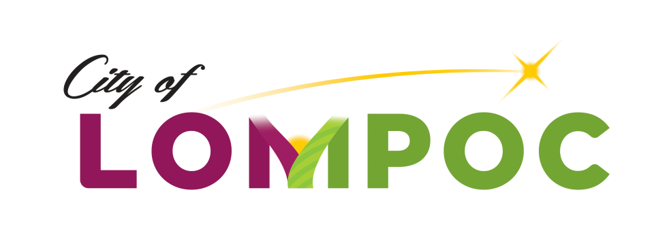

**HUMAN SERVICES COMMISSION**

**Special Meeting Minutes for**

**March 3, 2020**

**Council Chambers, Lompoc City Hall**

**100 Civic Center Plaza, Lompoc, CA 93436**

**3:30 pm**

**Commission Members Present:**

Mark Ashamalla, President

Pat Brady, Vice President

Karen Ortiz, Commissioner

Kenny Agbodike, Commissioner

**Commission Members Absent:**

None

**Council Liaison Present:**

None

**Staff Present:**

Chanel Ovalle, Community Development Program Manager

**Public Comment:**

**Written Communications:**

None

**Agenda Items:**

Meeting was called to order at 4:00 p.m.

1. Review and Decision of Community Action Committee’s Appeal of City of Lompoc 2020-21 CDBG Human Service Grant Application for Funding –

It was moved by Commissioner Brady and seconded by Commissioner Agbodike that the Community Action Commission’s Appeal be approved to interview agency. and deem them eligible to be included in the deliberations for grants.

Vote: The motion passed 4-0

1. Interview of Community Action Commission -

Ms. Ovalle gave an overview of the interview process: each interview would be 20 minutes in total to include introduction of everyone present and their title, a 5 minute summary of program and highlights by agency and 15 minutes for Commissioner questions and answering period. Between interviews, commissioners will have 10 minutes to add notes to their Application Rating Forms.

The agency interview was conducted with the following agency representative present: Patricia Keelean, Executive Director.

Motion: It was moved by Commissioner Ortiz and seconded by Commissioner Brady that Community Action Commission be granted $15,000 from the CDBG Human Service Grant Program.

Vote: The motion passed 4-0

**Adjournment**

Adjournment at 4:35 pm until next meeting on April 6, 2020.

Approved by Commission action on ­­­­­­­­­­­­­­­­ ________, 2020:

*/Chanel Ovalle/_________________________*

Chanel Ovalle, Community Development Program Manager