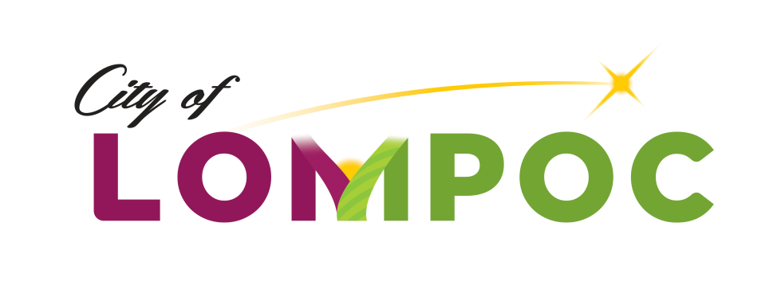

**HUMAN SERVICES COMMISSION**

**Regular Meeting Minutes for**

**February 23, 2020**

**Council Chambers, Lompoc City Hall**

**100 Civic Center Plaza, Lompoc, CA 93436**

**3:30 pm**

**Commission Members Present:**

Mark Ashamalla, President

Pat Brady, Vice President

Karen Ortiz, Commissioner

Kenny Agbodike, Commissioner

**Commission Members Absent:**

None

**Council Liaison Present:**

None

**Staff Present:**

Chanel Ovalle, Community Development Program Manager

**Presentations**

None

**Oral Communications**

None

**Agenda Items**

Meeting was called to order at 3:45 p.m.

1. Good Samaritan Shelter’s Interview for City of Lompoc 2020-21 CDBG Human Services Grant Funding -

Ms. Ovalle gave an overview of the interview process: each interview would be 20 minutes in total to include introduction of everyone present and their title, a 5 minute summary of program and highlights by agency and 15 minutes for Commissioner questions and answering period. Between interviews, commissioners will have 10 minutes to add notes to their Application Rating Forms.

Agency Interviews conducted are as follows:

Good Samaritan Shelter interview started at 3:45 pm with the following agency representatives present: Brian Halterman, Sylvia Bernard and Hector Hiron.

1. Approval of Regular Meeting Minutes of January 23, 2020 - Motion: It was moved by Commissioner Brady and seconded by Commissioner Agbodike that the minutes be approved as submitted.

Vote: The motion passed 4-0

1. Approval of Special Meeting Minutes of January 27, 2020 - Motion: It was moved by Commissioner Brady and seconded by Commissioner Agbodike that the minutes be approved as submitted.

Vote: The motion passed 4-0

1. Public Comment – None
2. Staff Updates / Announcements
3. Commissioner Updates / Announcements – Commission voted to cancel next regular meeting in March for lack of business.

Motion: It was moved by Commissioner Ortiz and seconded by Commissioner Brady that the March meeting be canceled.

Vote: The motion passed 4-0

1. Next Meeting Agenda Items The commission asked that the following items be on the next agenda for April 6, 2020:

* Approval of Regular Meeting Minutes
* Public Comment
* Staff Updates / Announcements
* Commissioner Updates / Announcements
* Next Meeting Agenda Items
* Deliberations

1. 2020-21 Human Services Grant Deliberations –

The Commission deliberated on Grant amounts.

Motion: It was moved by Commissioner Ortiz and seconded by Commissioner Brady that the Human Service Grant Program distribute grants as follows:

1. Child Abuse Listening Meditation (CALM) - $15,000
2. Good Samaritan Shelters - $15,000
3. North County Rape Crisis and Child Protection Center - $15,000
4. Transitions Mental Health Association - $15,000
5. An amount not to exceed $5,000 to purchase an application program such as Zoom Grants for the following Grant Year 2021-2022.

Vote: The motion passed 4-0

**Written Communications**

None

**Adjournment**

Adjournment at 4:30 pm until next meeting on April 6, 2020.

Approved by Commission action on ­­­­­­­­­­­­­­­­ ________, 2020:

*/Chanel Ovalle/_________________________*

Chanel Ovalle, Community Development Program Manager