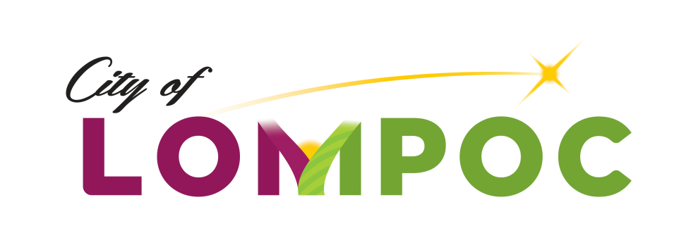

**HUMAN SERVICES COMMISSION**

**Special Meeting Minutes for**

**January 27, 2020**

**Council Chambers, Lompoc City Hall**

**100 Civic Center Plaza, Lompoc, CA 93436**

**4:00 pm**

**Commission Members Present:**

Mark Ashamalla, President

Pat Brady, Vice President

Karen Ortiz, Commissioner

Kenny Agbodike, Commissioner

**Commission Members Absent:**

None

**Council Liaison Present:**

None

**Staff Present:**

Chanel Ovalle, Community Development Program Manager

**Public Comment (3 Minute Maximum)**

Sylvia Barnard Executive Director of Good Samaritan addressed the commission requesting the Commission reconsider the agency’s application for City of Lompoc for 2020-21 CDBG Human Services Grant Funding.

**Written Communications**

None

**Agenda Item**

Meeting was called to order at 4:00 p.m.

1. Review and Decision of Good Samaritan Shelters’ Appeal of the City of Lompoc for 2020-21 CDBG Human Services Grant Funding -

Motion: It was moved by Commissioner Ortiz and seconded by Commissioner Agbodike that Good Samaritan’s City of Lompoc for 2020-21 CDBG Human Services Grant Application be accepted for possible funding.

Vote: The motion passed 4-0

**Adjournment**

Adjournment at 4:45 pm until next meeting in February 3, 2020.

Approved by Commission action on ­­­­­­­­­­­­­­­­ ________, 2020:

*/Chanel Ovalle/_________________________*

Chanel Ovalle, Community Development Program Manager