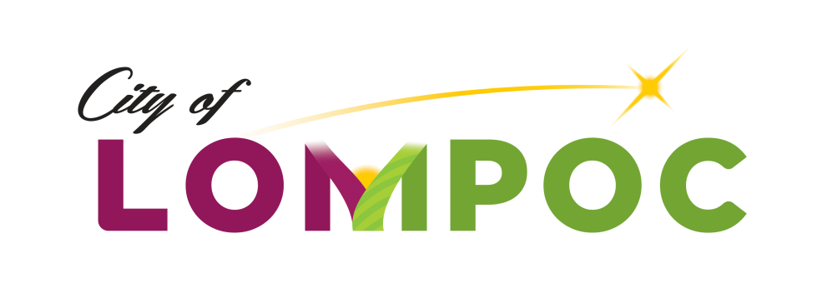

**HUMAN SERVICES COMMISSION**

**Regular Meeting Minutes for**

**January 23, 2020**

**Council Chambers, Lompoc City Hall**

**100 Civic Center Plaza, Lompoc, CA 93436**

**4:00 pm**

**Commission Members Present:**

Mark Ashamalla, President

Pat Brady, Vice President

Karen Ortiz, Commissioner

Kenny Agbodike, Commissioner

**Commission Members Absent:**

None

**Council Liaison Present:**

None

**Staff Present:**

Chanel Ovalle, Community Development Program Manager

**Presentations**

None

**Oral Communications**

None

**Agenda Items**

Meeting was called to order at 4:02 p.m.

1. Approval of Regular Meeting Minutes of December 2, 2019 –

Motion: It was moved by Commissioner Brady and seconded by Commissioner Ortiz that the minutes be approved as submitted.

Vote: The motion passed 4-0

1. Public Comment –

Brian Halterman from Good Samaritan addressed the commission stating the agency submitted an appeal to the City of Lompoc for 2020-21 CDBG Human Services Grant Funding and requested the Commission reconsider the agency’s application for 20-21 funding.

1. Staff Updates / Announcements -

The commission was informed that staff received a resignation letter from Commissioner Maria Morales resigning from the commission.

Staff verbally corrected the agenda stating the Council Liaison for the quarter is Councilmember Mosby not Councilmember Vega.

Ms. Ovalle highlighted the 2020-21 CDBG Human Services Grant Application Log, which listed agencies that attended the Mandatory Application Workshop and submitted an application. The log reflected notes that deemed the application eligible or ineligible for funding reflecting out of the 7 applications received 3 applicants were eligible for their application was complete and the program complied with CDBG requirements.

The 2019-20 Human Services Activities End of Year Performance Analysis Report was highlighted by Ms. Ovalle. Ms. Ovalle stated there were agencies out of compliance that would have to adopt certain HUD requirements as presented to the City of Lompoc during its Equal Opportunity and Fair Housing HUD Audit conducted in 2018 in order for the agency to receive its 2019-20 allocated grant. Ms. Ovalle informed the Commission that agencies would have to become compliant and submit their request for the full amount of their grant allocations by April 10, 2020. For agencies not in compliance and allocations not requested by the deadline of April 10, 2020 the commission may have to meet to reallocate funding.

1. Commissioner Updates / Announcements – None
2. Planning for Deliberations –

Motion: It was moved by Commissioner Brady and seconded by Commissioner Agbodike that the commission’s deliberations for the 20-21 CDBG/Human Service Grant Funding be held on February 3, 2020 during its regular meeting.

Vote: The motion passed 4-0

1. Next Meeting Agenda –

The commission asked that the following items be on the February agenda:

* Approval of Regular Meeting Minutes
* Public Comment
* Staff Updates / Announcements
* Commissioner Updates / Announcements
* Next Meeting Agenda Items
* Deliberations

1. 2020-21 CDBG Human Service Grant Applicant Interviews –

Ms. Ovalle gave an overview of the interview process: each interview would be 20 minutes in total to include introduction of everyone present and their title, a 5 minute summary of program and highlights by agency and 15 minutes for Commissioner questions and answering period. Between interviews, commissioners will have 10 minutes to add notes to their Application Rating Forms.

Agency Interviews conducted are as follows:

Child Abuse Listening Mediation (CALM) at 4:30 pm with the following agency representatives present: Adolfo Garcia/Director of Clinical Operations, Mireya Hernandez/Finance Manager, Yvonne Nelso/Lompoc Regional Manager and Ashley Costa/a public program supporter.

North Rape Crisis and Child Protection Center at 5:00 pm with the following agency representatives present: Ann McCarty/Executive Director and Karin Powers/Director of Finance and Human Services.

Transitions Mental Health at 5:30 pm with the following agency representatives present: Steve Greene/Program Manager and Sandy Rives/Program Supervisor.

**Written Communications**

Ms. Ovalle passed out a copy of the Good Samaritan Appeal Letter with copies of the their submitted 2019-20 and 2020-21 City of Lompoc CDBG Human Services Applications for Grant Funding for the commission to review. As the information was passed out Ms. Ovalle instructed commissioners that no discussion could be made regarding the information for it was not on the agenda and that the Commissioner President would call a special meeting to discuss the matter on a later date of which the commission would receive notice.

**Adjournment**

Adjournment at 6:15 pm until next meeting in February 3, 2020.

Approved by Commission action on ­­­­­­­­­­­­­­­­ ________, 2020:

*/Chanel Ovalle/_________________________*

Chanel Ovalle, Community Development Program Manager