Beautification & Appearance Commission

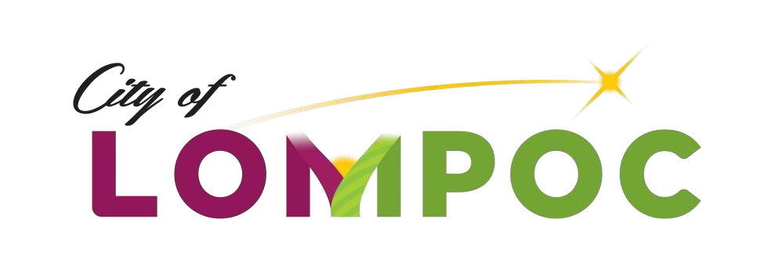

Special Meeting Agenda

Wednesday, January 8, 2020 at 4:30 PM

City Hall Administrative Conference Room

100 Civic Center Plaza, Lompoc, CA

*Please be advised that, pursuant to State Law, any member of the public may address the Commission concerning any Item on the Agenda, before or during Commission consideration of that Item.*

*Any documents produced by staff and distributed to the Commission regarding any item on the Agenda will be made available for public inspection in the lobby of Lompoc City Hall at 100 Civic Center Plaza between 9 am and 5 pm Monday through Friday, and the Lompoc Library Information Desk at 501 E. North Avenue between 10 am and 7 pm Monday through Thursday and 1pm and 5pm Friday and Saturday.*

*In compliance with the Americans with Disabilities Act, if you need special assistance to participate in this meeting, including review of the Agenda and related documents, please contact the Urban Forestry Division at (805) 875-8034 at least 72 hours prior to the meeting. This will allow time for the City to make reasonable arrangements to ensure accessibility to the meeting.*

**ROLL CALL:** Vice-Chairperson: Susan Gallacher

Commissioner: Rosemary Holmes

Commissioner: Judith McKinnon

Commissioner: Kristofer Clark

City Staff/Urban Forestry Supervisor/Commission Secretary: Sean O’Neil

City Staff/Office Staff Assistant II: Kathleen Forbes

**REQUEST TO SPEAK:** A member of the public may address the Beautification & Appearance Commission regarding any scheduled agenda item. Any person wishing to address the Commission should inform the Commission Secretary/Recorder at the beginning of the Meeting. The Commission, upon majority vote, may decline to hear a speaker on the grounds that the subject matter is beyond their jurisdiction.

**PUBLIC COMMENT:** At the beginning of the 4:30 p.m. session of each regular Beautification & Appearance Commission meeting, and at the beginning of each special Commission meeting, any member of the public may address the Commission on any item not on the agenda. The total amount of time for public comments will be 15 minutes, and no individual speaker may speak for more than two minutes.

BCSA 2020 01 08 Lompoc Beautification & Appearance Commission Agenda Page 1 of 2

**REGULAR BEAUTIFICATION & APPEARANCE COMMISSION MEETING**

**ORDER OF BUSINESS**

4**:30 P.M. -** **CALL TO ORDER**

# ROLL CALL

**PUBLIC COMMENT** Any member of the public may address the Commission for up to two minutes on any subject within the jurisdiction of the Commission that is not scheduled for a public discussion before the Commission.

**WRITTEN COMMUNICATIONS**

**COMMISSION AND STAFF COMMUNICATIONS**

# CONSENT CALENDAR

1. Approval of Minutes – For Action.

Recommendation: That the Commission waive the reading and approve the Minutes of the Regular Meeting of 12.11.2019 and the Special Meeting – Holiday Decorating Contest Judging of 12.09.2019.

# UNFINISHED BUSINESS

# NEW BUSINESS

1. Discussion of the current make-up and meeting days, times, and locations of the Beautification & Appearance Commission. Provide suggestions or requests to Council of any revisions to the current make-up and/or meeting days, times, and locations of the Beautification & Appearance Commission.
2. 2020 Arbor Day/Recognition Grove Event.
3. Set Date for Annual Field Inspection.
4. Election of Chairperson and Vice-Chair Positions.

**STAFF ITEMS**

**COMMISSIONER REQUESTS**

# ADJOURNMENT

I hereby certify under penalty of perjury under the laws of the State of California that the foregoing agenda was posted on the City Hall bulletin board not less than 72 hours prior to the meeting. Dated this 8th day of January 2020.

# /*Sean O’Neil*/_____________

Sean O’Neil, Urban Forestry Supervisor

BCSA 2020 01 08 Lompoc Beautification & Appearance Commission Agenda Page 2 of 2