**Contest Rules:**

1. Entrant information must NOT appear on the front of the photo. All information MUST be on the back of the photo and include:
   1. An arrow in the center indicating the top of the photo.
   2. Category, Title of Photo, Entrants name, address and phone number.
2. Name of the Photo must be printed on the front bottom right corner.
3. All prints must be 8X10” and mounted on a white foam board. Photo must be secured on the board with glue or mounting spray. No tape or hinges will be accepted.
4. No pictures of pictures allowed.
5. A maximum of 6 entries per exhibitor and only 3 photos per category.
6. Each photo can only be entered into one category – no multiple categories photos.
7. All entries must be of good taste and suitable for family viewing as determined by event coordinator.
8. The Judge and/or event coordinator reserves the right to disqualify any photo for any matter of content or inappropriateness.
9. All judging is closed to the public and all decisions are final.

**Criteria for Judging Photography:**

Impact – 35%

Effect on the viewer, strong emphasis on subject, readability, creativity of vision.

Composition – 35%

Coherent design or arrangement of elements.

Technical Quality – 30%

Detail in highlights and shadows, sharpness, use of shutter speeds, depth of field, color balance, tonal values, and mastery of techniques.

**Total value – 100%**

**Who Can Enter?**

Anyone! Amateurs, professionals, youth and teens.

**What Kind of Photos?**

Nature and Landscape: pictures that include landscapes, outdoor scenes, nature images, sunsets, urban landscapes, seascapes, cityscapes, farms and other imagines of this nature.

Animals: pictures of pets, wild or zoo, farm and even insects.

**Categories:**

Youth – K through 8th grade

Teen – 9th through 12th grade

Adult Amateur – 18 & older

Adult Professional – 18 & older

Nature and Landscape – all ages

Faces – all ages

**Awards:**

First Place – Ribbon, Category Prize

Second – Ribbon

Third – Ribbon

Best in Show – Ribbon

**Entry Procedure:**

1. Complete registration form
2. Submit photo (8X10” centered and adhered to an 11X14” foam board)
3. Fee entry fees - $3.00/photo
4. **A digital copy must be sent to** [s_slavens@ci.lompoc.ca.us](mailto:s_slavens@ci.lompoc.ca.us)



Lompoc Valley

Photography Competition

**Saturday, October 26, 2019**

Dick DeWees Community & Senior Center

1120 W Ocean Ave

Lompoc, CA 93436



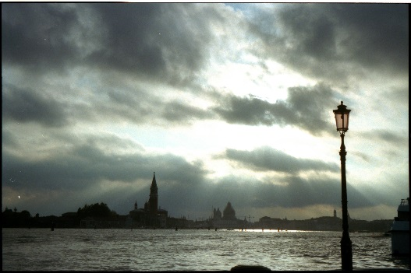

**Entry:**

**ALL PHOTOS MUST BE PRE-REGISTERED**

All entries can be received between

October 1st through October 18th

All entries go to Anderson Recreation Center

125 W Walnut Ave

Lompoc, CA 93436