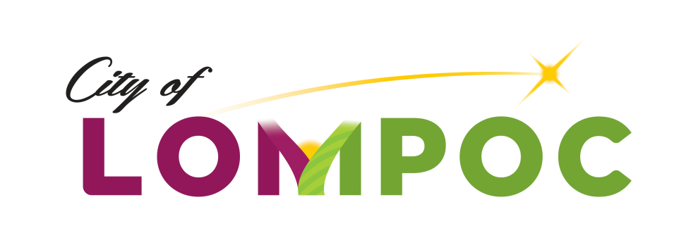

Youth Commission Special Meeting Agenda

May 20, 2019 - 7:00 PM

Anderson Recreation Center

125 West Walnut Avenue, Lompoc, CA

|  |
| --- |
| *Please be advised that, pursuant to State Law, any member of the public may address the Commission concerning any Item on the Agenda, before or during Commission consideration of that Item.*  *Any documents produced by staff and distributed to the Commission Members regarding any item on the Agenda will be made available for public inspection in the lobby of Lompoc City Hall at 100 Civic Center Plaza between 9 am and 5 pm Monday through Friday, and the Lompoc Library Information Desk at 501 E. North Avenue between 10 am and 7 pm Monday through Thursday and 1pm and 5pm Friday and Saturday.*  *In compliance with the Americans with Disabilities Act, if you need special assistance to participate in this meeting, including review of the Agenda and related documents, please contact Johanna Kinard or the Recreation Division at (805) 875-8100 at least 72 hours prior to the meeting. This will allow time for the City to make reasonable arrangements to ensure accessibility to the meeting.* |

**ROLL CALL**

Commissioner Jessica Streett, Chair

Commissioner Scott Betschel

Commissioner Tyler Evangelista

Commissioner Tori Gordon

Commissioner Isabel Hapil

Commissioner Beverly Kennedy

Commissioner Emily March

Commissioner Karla Paniagua

Commissioner Tyler Rainwater

Commissioner Melissa Resendiz

**ORAL COMMUNICATIONS (Maximum of 5 Minutes):** (At this time, please direct comments to the Youth Commission regarding agenda items if you are not able to stay until that matter is discussed, or issues not on the Agenda but within the jurisdiction of the Youth Commission.)

**PRESENTATIONS:**

**CONSENT CALENDAR:**

1. Approval of Minutes from Regular Meeting on April 29, 2019.

**UNFINISHED BUSINESS:**

**WRITTEN COMMUNICATIONS:**

**NEW BUSINESS:**

1. 2020 TOTAL Conference
   1. Potential Dates
   2. Theme

**ORAL COMMUNICATIONS (2 Minutes Maximum):**

**COMMISSION REQUESTS, COMMENTS, AND MEETING REPORTS:**

**STAFF REQUESTS AND ANNOUNCEMENTS:**

1. Special Event Updates: Movies in the Park, 4th of July and Triathlon – Oral Report by Johanna Kinard, Recreation Coordinator

**ADJOURNMENT:**

Lompoc Youth Commission will adjourn to a Regular Meeting on August 26, 2019 at 7:00 pm at the Anderson Recreation Center, 125 West Walnut Avenue.

I hereby certify under penalty of perjury under the laws of the State of California that the foregoing agenda was posted on the City Hall bulletin board not less than 72 hours prior to the meeting. Dated this 16th day of May, 2019.

________________________________

Johanna Kinard, Recreation Coordinator